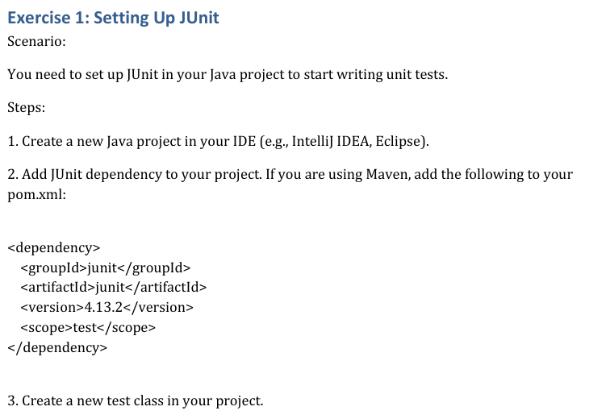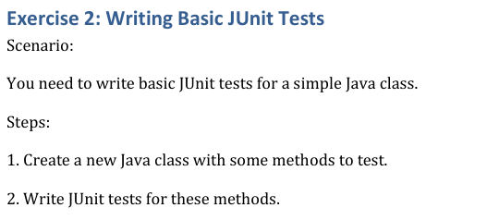

**SOLUTION:**

**Step 1: Project Setup**

**Action:**

* Created a Maven project using the following command in terminal:

mvn archetype:generate -DgroupId=com.example -DartifactId=demo -DarchetypeArtifactId=maven-archetype-quickstart -DinteractiveMode=false

**Project Folder Structure:**

demo/

├── pom.xml

└── src/

├── main/java/com/example/App.java

└── test/java/com/example/AppTest.java

**Snapshot:**  
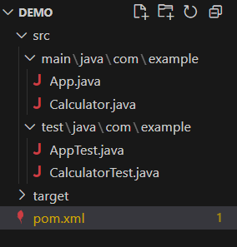

**Step 2: Add JUnit Dependency**

**Updated pom.xml:**

<dependencies>

<dependency>

<groupId>junit</groupId>

<artifactId>junit</artifactId>

<version>4.13.2</version>

<scope>test</scope>

</dependency>

</dependencies>

**Snapshot:**

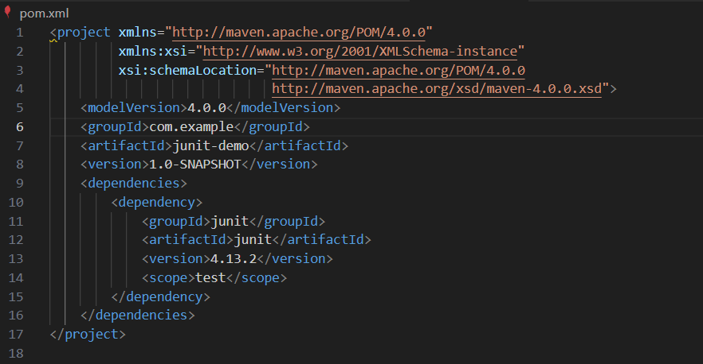

**Step 3: Java Class Implementation**

**File:** src/main/java/com/example/Calculator.java

package com.example;

public class Calculator {

public int add(int a, int b) {

return a + b;

}

}

**Step 4: Unit Test Implementation**

**File:** src/test/java/com/example/CalculatorTest.java

package com.example;

import static org.junit.Assert.assertEquals;

import org.junit.Test;

public class CalculatorTest {

@Test

public void testAdd() {

Calculator calc = new Calculator();

int result = calc.add(2, 3);

assertEquals(5, result);

}

}

**Step 5: Running the Test**

**Command:**

mvn clean test

**Snapshot of Terminal Output:**  
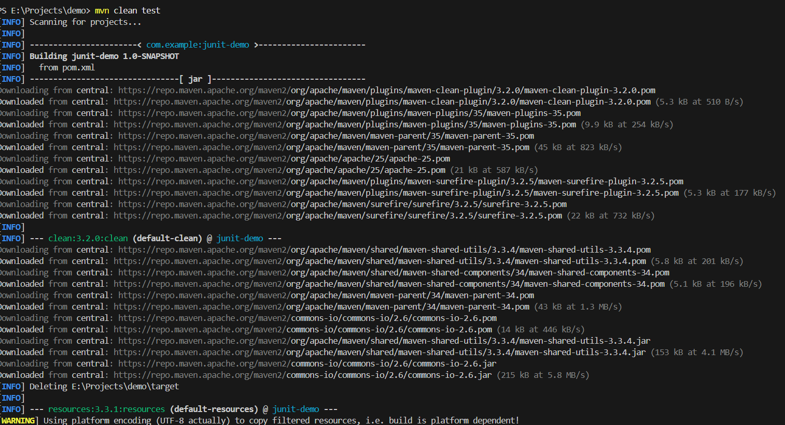

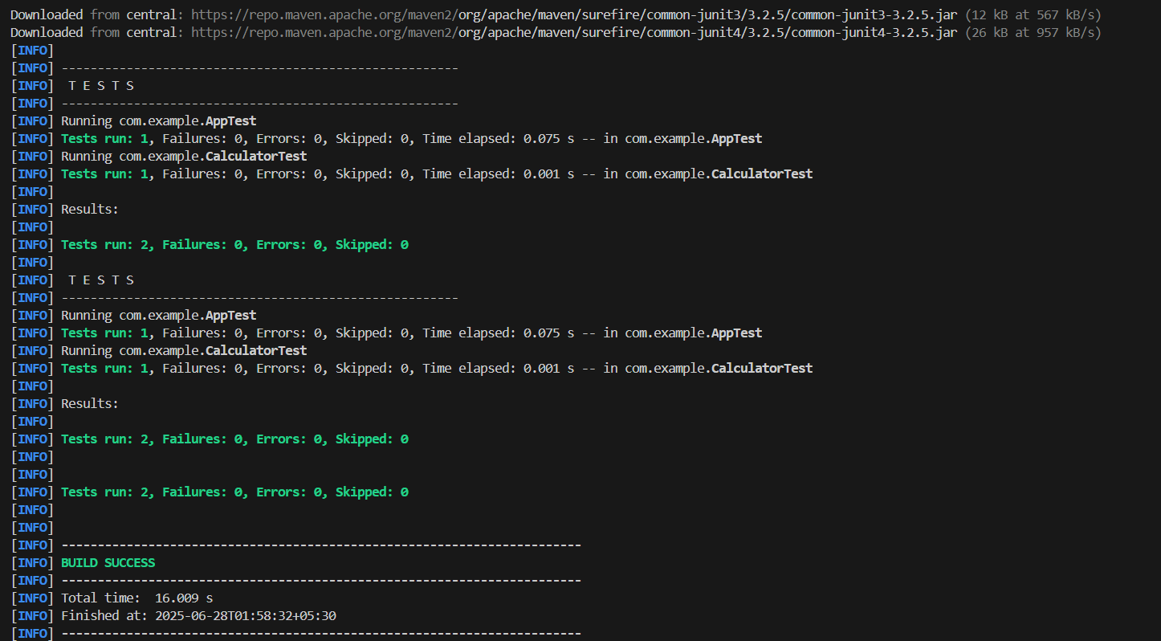

**Conclusion:**

* JUnit 4 successfully set up and verified with a basic test case.
* Environment is now ready for writing and running more unit tests.